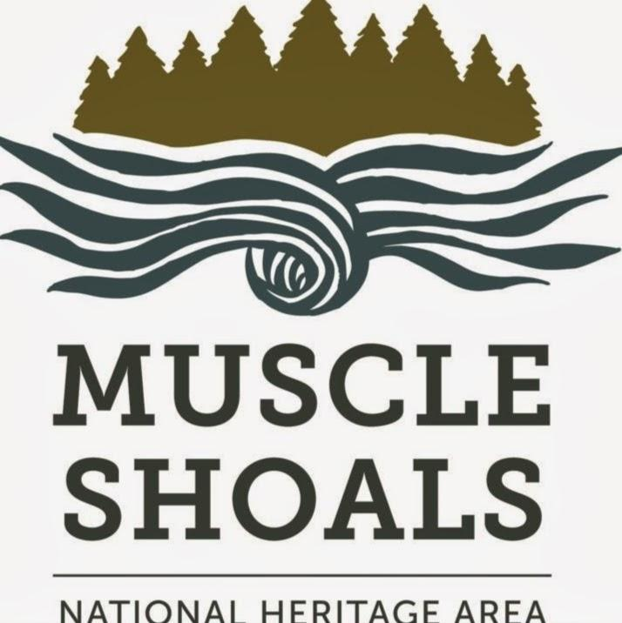 MSNHA Grant Guidelines

Who we are & what we do: The Muscle Shoals National Heritage Area, which operates under the University of North Alabama, was designated by Congress in 2009 to preserve history & culture in the Tennessee River’s northwest Alabama counties: Colbert, Franklin, Lauderdale, Lawrence, Limestone & Morgan. We promote cultural tourism through education, preservation & conservation. Our mission is to inform & educate; develop & interpret historic sites; create living-history experiences; and chronicle landscape evolution, for the largest audience possible.
What we fund: Reimbursable amounts of $1,000-$7,500 per project in categories of
● Assessment -- Hiring a consultant to address preservation needs or problems such as establishing environmental monitoring programs and developing plans for improving environmental conditions, security, or fire protection for collections; studying light levels in exhibition and storage spaces and recommending appropriate methods for controlling light and reducing damage to collections; developing detailed plans for improving storage or rehousing a collection; or assessing conservation-treatment needs of selected items in a collection.
● Preservation -- Purchasing supplies and paying labor costs for basic preservation and preservation projects.
● Interpretation -- Enhancing museums & sites by developing document/volunteer training programs, cataloging & researching collections, writing exhibit text & other interpretive materials, developing long-term interpretive plans, installing interpretative panels, researching & installing historical markers and developing & printing educational materials.
● Workshops -- Funding workshops & training sessions for staff, volunteers & others.
● Archiving -- Initiating national & state historic registrations; developing cemetery restoration programs; digitizing documents and photos; and preserving collections such as books & journals, archives & manuscripts, prints & photographs, moving images, sound recordings, architectural & cartographic records, decorative & fine art objects, textiles, archaeological & ethnographic artifacts, furniture and historical objects.
● Events – Living-history events such as concerts, plays, walking tours & period banquets & balls.
● Musical productions and art projects – Presenting performances and showings that are related to MSNHA’s historical and cultural themes and open to the public.
● Bus travel – Transporting K-12 student groups to MSNHA partner sites.
Who and what are eligible: Non-profits, local governments, businesses, schools and other groups & organizations may apply. Applicants and projects must be in MSNHA’s six-county region. Projects must be linked to MSNHA’s mission & one of its three themes and fit within a category detailed above. Grantees with an open application can’t apply for additional funds for the same project until they've completed that project’s scope of work unless other arrangements are made.
Matching contributions: Applicants must provide at least a dollar-for-dollar match; we encourage overmatch. Match & overmatch must be from non-federal sources: foundation or private-sector grants, the applicant organization, project partners, in-kind non-cash contributions from professionals and/or volunteers ($23/hour, $12.50/hour students participating as part of an enrolled-course assignment, verified hourly rate for professionals) or any combination thereof. In-kind contributions may be labor, services, materials, equipment, supplies, and/or travel expenses necessary for project objectives. Purchases of real property, overhead & general administrative costs don’t count toward matches. Matching & overmatching contributions must begin after grant’s award date. Use website form(s) for submitting volunteer & in-kind documentations.
How to apply:
● Download or print application, fill it out, scan the completed application if needed, and email it plus attachments -- letter indicating IRS 501(c)(3) tax-exempt status if applicable, IRS W-9 form & letter signed by your organization’s financial officer or authorized representative verifying amounts & sources of matching funds -- to ebrhodes@una.edu.
● Expenses & match/overmatch contributions submitted in your final report MUST fall between the project’s start & end dates on the application. Anything dated outside of that range will not be accepted. Let us know if your project requires performance or venue deposits before contract is signed.
● Expenses for reimbursement and contributions to match & overmatch must be specific. These will be included in your contract, and documentation must be submitted with your final report. Include a project budget (revenues and expenses) as specified in the application.
● Applicants may submit a draft application no later than 30 days before deadline. MSNHA will review application for completeness. A review doesn’t guarantee successful funding and will not include content.
How applications are scored:
● MSNHA selects qualified volunteer scorers. Scorers remain anonymous & do not evaluate applications with which they have potential conflicts of interest.
● Scoring categories include contributions to MSNHA (sustaining our mission & fitting into one of our three themes), innovative approach, potential to reach goals & objectives, clarity of proposal and budget appropriateness. Applicants may request copies of their scoring sheets.
● Extra points awarded for overmatch.
Terms of grant awards:
● Grant amount -- $1,000-$7,500 per proposed project. Funds are provided via reimbursement; grant funds are released only after project costs are incurred & paid for by the grant recipient. Expenses incurred before the date of the grant’s approval will not be reimbursed. MSNHA must receive applicant’s signed contract before any work to be covered by the grant award begins.
● Expenses to be reimbursed & match and overmatch to be submitted must be specified in the application & contract and documented in the final financial report. MSNHA will release funds only for those approved expenses & matching contributions. Notify MSNHA before the project end date if revisions to the contract are necessary..
● Grantee must submit a completed final report, financial report form & documentation of paid expenses & matches -- including receipts, paid invoices, and legible front & back copies of cancelled checks -- within fourteen days of paying the final expense. Expenses & match contributions must be those specified in contract. Use the website forms for volunteer sign-ins & documenting in-kind contributions of goods and services.
● Grants awarded per cycle – The number of grants awarded each cycle will vary. Applicants are eligible for only one grant award per fiscal year.
● Award period -- Grants are viable for one year from the project start date. If recipient can’t complete the project within the agreed-upon time, including adjustments to original schedule, MSNHA will terminate the contract.
● Grant contract -- Funds are administered through a contract between MSNHA and the applicant. The award is not official until all parties have signed, and no money spent before MSNHA receives the signed contract will be reimbursed. Funds are not released until the grant recipient submits the agreed-upon documentation and MSNHA approves it.
● Project changes -- MSNHA must approve changes in the grant contract prior to initiation of such changes & prior to final-report submission. Email MSNHA about requested changes.
● Grant acknowledgment/publicity -- Grantees must sign the provided publicity agreement & acknowledge MSNHA in all materials pertaining to the grant award & project. Grantees must notify Congressional & state representatives in writing that their project has received an MSNHA grant award through MSNHA. Include copies of letters & publicity with final report.
● Final reports – Within fourteen days of the project’s end date, grant recipients must submit the completed final report along with the final financial form.
● Please note that MSNHA does not write the grant award checks -- UNA does. Once you submit your final report & required documentation, your paperwork embarks on a weeks-long process through various federal & university offices until everything is approved & you receive your check. The best way to avoid delays is to scrupulously follow all instructions & contact us as soon as you have a question.
● A short time after project completion, MSNHA staff will visit you to document proof of completion for UNA auditors, including photos & a brief wrap-up of the project.
Grantee responsibilities – federal regulations. Grant awards from MSNHA are made with federal funds received from the National Park Service. Because the grant dollars are federal in origin, grant recipients must comply with applicable federal regulations regarding the use and administration of federal funds. Please also see provided document on NPS regulations.
● Code of Federal Regulations. The following Federal regulations are incorporated by reference into this Agreement (full text can be found at http://www.ecfr.gov:)
a) Administrative Requirements: 2 CFR, Part 200 – Uniform Administrative Requirements, Cost Principles, and Audit Requirements for Federal Awards, in its entirety;
b) Determination of Allowable Costs: 2 CFR, Part 200 – Uniform Administrative Requirements, Cost Principles, and Audit Requirements for Federal Awards, Subpart E; and
c) Audit Requirements: 2 CFR, Part 200 – Uniform Administrative Requirements, Cost Principles, and Audit Requirements for Federal Awards, Subpart F.
d) Code of Federal Regulations/Regulatory Requirements: 2 CFR Part 182 & 1401, “Government–wide Requirements for a Drug–Free Workplace”; 2 CFR 180 & 1400, “Non–Procurement Debarment and Suspension”, previously located at 43 CFR Part 42, “Governmentwide Debarment and Suspension (NonProcurement)”; 43 CFR 18, “New Restrictions on Lobbying”; 2 CFR Part 175, “Trafficking Victims Protection Act of 2000”; FAR Clause 52.203–12, Paragraphs (a) and (b), Limitation on Payments to Influence Certain Federal Transactions; 2 CFR Part 25, System for Award Management (www.SAM.gov) and Data Universal Numbering System (DUNS); and 2 CFR Part 170, “Reporting Subawards and Executive Compensation.”
● Grantees must comply with all applicable federal laws including but not limited to Section 106 of the Historic Preservation Act, Secretary of Interior Standards, the Native American Graves Protection and Repatriation Act, the National Environmental Policy Act, Title IV of the Civil Rights Act of 1964, Title IX of the Education Amendments of 1972, The Age Discrimination Act of 1975, and the Americans with Disabilities Act. More information can be found at http://www.achp.gov/106summary.html, http://www.nps.gov/nagpra/, http://www.cr.nps.gov/local-law/fhpl_ntlenvirnpolcy.pdf, and http://www.ada.gov/
● Grantees must allow inspection of program records and project by MSNHA and authorized federal agencies during the project and for up to three years following project completion.
Grantee responsibilities – state regulations
● Grantees awarded $5,000 or more must submit the state vendor disclosure form, signed & notarized.
● Projects also may require review by the Alabama Historical Commission to determine adverse impacts to historic or archaeological sites and if the project fits the Alabama Statewide Comprehensive Historic Preservation Plan. Applicants may be required to submit detailed project information, maps, and photographs. Visit https://ahc.alabama.gov/ for details. Projects may also be subject to review under the National Environmental Policy Act.
Timeline and checklist for grant process:
- Read these guidelines & the grant application (when open) carefully to ensure your project meets all criteria & you can provide all required documentation. Incomplete applications & those using forms other than those provided will be discarded.
- Submit application by deadline, using all required forms. You may submit a draft up to 30 days before the deadline for MSNHA staff to check for completeness, although this does not guarantee application approval.
- We’ll email you immediately to verify receipt of your application & notify you of our funding decision within 120 days of the deadline. Funding of your grant award is contingent on approval of final report.
- MSNHA prepares your grant contract, a legal document stating the terms of your grant project. What’s specified in the contract must be what exactly what you submit in your final report. Email us with requests for contract revisions (start & end dates, scope & purpose of work, expenses & match/overmatch contributions) during the project. Once you submit your final report, the contract cannot be revised. Your final report will be approved & your reimbursement check sent only if the start & end dates, scope of work, purpose of work, expenses & match/overmatch contributions in your final report are exactly the same as specified in your contract.
- Your contract is reviewed & signed by various University of North Alabama department heads. We may come back to you with requests for additional information & clarifications as needed.
- We email you your contract. Please review it carefully to ensure that all information is correct & you can provide all required documentation. Email us immediately if something needs to be changed. When you’re sure everything is correct, print the contract and sign & date it. Save a copy for yourself & email us a copy. The date of your signature must be on or before the project’s start date--your project cannot start until after you sign the contract. As soon as you sign & date it and email it to us, the contract is actionable & you may begin your project.
- Along with your contract, we’ll also email you the publicity agreement. Print it, sign & date it, save a copy for yourself & email us a copy.
- As your project progresses, we’ll check in with you periodically. Email us immediately if you need to make a change in anything agreed to in the contract. Your final reports must duplicate EXACTLY what’s specified in the contract.
- Submit final reporting within 14 days of project completion. Use required forms & provide required documentation to ensure full reimbursement. Read guidelines on the final-report forms carefully; final reports that are incomplete, incorrect and/or do not duplicate exactly what’s specified in the contract will not receive full reimbursement.
- UNA mails your check to your mailing address.

For more information -- Emily Rhodes, grant administrator, MSNHA, UNA Box 5231 Florence, AL 35632-0001 (256) 765-5028 or ebrhodes@una.edu

