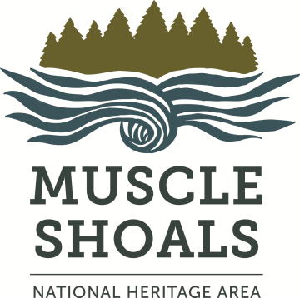
Muscle Shoals
National Heritage Area
Grants Publicity Agreement

We want people to know about MSNHA and its grant program -- our ability to fund future grants depends on our visibility to the public and legislators. You help when you agree to these points:
- Notifying Legislators -- Send a letter or email to your Congressional and Alabama state legislators notifying them that MSNHA has awarded you a grant. Include copies with your final report. MSNHA has a contact list if you need help with email addresses.
- Notifying the University of North Alabama -- Send a letter acknowledging MSNHA’s support of your project to
  - Dr. Kenneth Kitts, UNA president, president@una.edu
  - Dr. Ross Alexander, UNA vice president of academic affairs & provost, ralexander3@una.edu
  - Dr. Sarah Lynn Baird, interim dean, College of Arts & Sciences, sbaird@una.edu
- Publications -- Acknowledge MSNHA in all project-related published materials. Use any of the following three credit lines and include copies with your final report --
- This project is made possible by a grant from the Muscle Shoals National Heritage Area.
- This project made possible in part by a grant from the Muscle Shoals National Heritage Area.
- Support and funding provided by the Muscle Shoals National Heritage Area
- Links -- Link to the MSNHA website (www.msnha.una.edu) on your website, blog, e-newsletter and social-media platforms.
- Publicity & News Releases -- Acknowledge MSNHA’s support in project-related news releases. Include copies in your final report. We also have a presentation check if you want to arrange a photo for your website, newsletter, local newspaper, etc. Just let us know.
- MSNHA Logo – We will provide you with our logo to use in publicity upon request.
- Verbal Acknowledgment -- Provide verbal acknowledgment of MSNHA’s support in all public presentations, meetings, classes and/or workshops supported by the grant.
- Photographs -- Send photos of your grant project to the MSNHA intermittently while the project is ongoing. Include photos in the final report.
- Signage – MSNHA will provide display signage naming us as a sponsor of your project to be used at any meetings, news conferences, receptions, workshops, etc., upon request.
Provide copies of all letters, promotional materials and press clippings in your final report to the MSNHA. The final-report form is at www.msnha.una.edu.
Questions? Contact Emily Rhodes, MSNHA grants administrator, ebrhodes@una.edu, (256) 765-5028

Publicity Checklist
Grantees are to publicize events or portions of events for which they received MSNHA funding and credit MSNHA in that publicity. Please mark each box below if in agreement.
- I have read and agreed to the MSNHA grant publicity guidelines.
  - I agree to notify MSNHA of the exact date, time, and location of our public programs.
  - I agree to credit MSNHA in all project-related published materials, print, and online; in all project-related news releases; and all public presentations, meetings, classes, and/or workshops supported by the grant.
  - I understand that I must submit copies of the documents and materials outlined in the above publicity guidelines with the final report to receive award funds.
Sign and date below. Keep a copy of the signed agreement. Mail the original to MSNHA, UNA Box 5231, Florence AL 35632 or scan and email to ebrhodes@una.edu with the signed and dated grants contract.

I certify that _______________________________________________________ (organization name) will maintain and hold all public policy requirements throughout the process of the project.

____________________________________________ _____________________
Name of person authorized to represent organization Date

Contact Information:
Emily Rhodes, Muscle Shoals National Heritage Area grants coordinator
Phone -- (256) 765-5028
Email -- ebrhodes@una.edu

