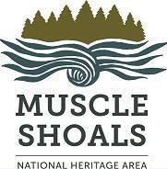

Muscle Shoals National Heritage Area UNA Box 5231
Florence, AL 35632
Volunteer Sign-in Sheet
Name/organization:
Print document in landscape format. Volunteers sign & date to certify their work & hours.
Work description must be specific. (Use back of sheet if needed)
When submitting this sheet with final reporting, grantee must include description of volunteer work & how it relates to grant project. (Attach as addendum to this sheet.)
•
•
•
Volunteer and “In-kind” Donations--For collaborative heritage
programming, the MSNHA may match its federal grant(s) with the fair value of contributed volunteers’ time, hours worked on another organization’s non-federal payroll, donated professional services, donated material goods & donated mileage, provided that the goods, services & time are not reimbursed from a federally funded source. This private investment in heritage programs enables MSNHA to fulfill its requirement to match every federal dollar 1:1 with non- federal dollars and to continue working on important local programs.
Program/project:
Dated signature of grantee/volunteer supervisor:

Date(s) | Name of Volunteer | Description of volunteer work done & contributed time  (volunteer, professional or on a non-federal payroll) | # of Hours | Miles Traveled

