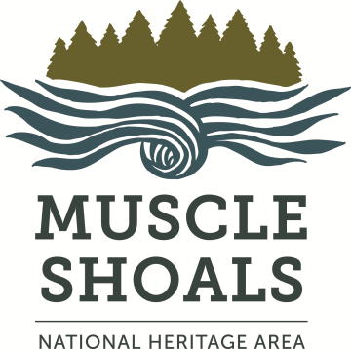
Muscle Shoals
National Heritage Area
Grant Final Report

Instructions: Submit this final report within fourteen days of project’s end date. Create your own text document using the format and headings from this form (copy and paste works well). Fill out the form, write your narrative save to your computer. Scan copies of materials as specified in the Grant Publicity Agreement -- photos, news releases and promotional materials acknowledging MSNHA’s grant award, project documents acknowledging MSNHA’s grant award and letters to Congressional and state representatives acknowledging MSNHA’s grant award. Combine those scans and the Final Report into one document named YOURORGANIZATION NAME_FINAL_2020 and email it to msnha@una.edu.
Grant Description
Name of organization:
Mailing address for grant correspondence:
Phone and email:
Name, phone, and email of project manager:
Project title & dates:
Reporting period (starts from when you signed grant contract and finishes on due date of this report):
Grant amount: Total project budget:
Additional sources of funding:
The answers to the following questions give an overview of the intent of the grant and compares how the project did to what was anticipated. They also provide insight into how this grant affected the community you serve and your organization.

Description of Outputs and Outcomes (200-300 words)
- What did you aim to accomplish with your project? What progress did you make toward realizing the output(s) and outcome(s), as specified in the Executive Summary section of your Grant Application, of this project?
- How did internal or external factors, either positive or negative, (e.g. new staff, unanticipated delays, increased funding, a partner organization stopped providing services, etc.) affect implementation of your project or the anticipated timeline?
Lessons Learned (200-300 words)
- What did you, your staff, and/or volunteers learn from this project about your organization and/or its clients? How will those lessons impact your future planning, performance, or services?
- What was the greatest strength of the project? What disappointed you in the implementation of this project? What you would do differently?
- If the project involved collaborating with another/other organization(s), discuss the collaboration’s effect on the project and how this process influenced your organization and your partner(s).
Optional Comments
We want to make our grants process better. Thank you for your feedback!
- What other type(s) of non-financial supports that would have facilitated this project (capacity-building, introductions, knowledge-sharing session, resources, or leveraging collaborations with other stakeholders) could MSNHA have offered you?
- How can we improve our grant application and/or reporting procedures?
Budget Information
Include the required Final Financial Report spreadsheet with all requested documentation..

For more information
Contact Emily Rhodes, MSNHA grants coordinator, ebrhodes@una.edu or (256) 765-5028.

Checklist for Grants Final Report

Completed Final Financial Report spreadsheet. Expenses submitted must be the same as specified in your grant contract.
Documentation of cost – copies of invoices and/or receipts
Documentation of payment – copies of cancelled checks (legible fronts and backs) and/or credit-/debit-card receipts
Documentation of award match & overmatch using forms on MSNHA website
Documentation of mileage, if reimbursable, as per spreadsheet instructions
Documentation of labor, if reimbursable, as per spreadsheet instructions
Invoice from you, the grant applicant, to MSNHA that bills MSNHA for the amount of the grant award. Our fiduciary, the University of North Alabama, requires this invoice.
Completed Grant Final Report
Copies of letters to Congressional and state representatives notifying them that MSNHA awarded you a grant, as per publicity agreement
Copies of all project-related materials that acknowledge your MSNHA grant,
as per publicity agreement
Copies of news releases acknowledging your MSNHA grant, as per publicity agreement
Photos of grant project and progress and/or implementation, as per publicity agreement

Congratulations! You’re almost there! Combine everything into one document named YOURORGANIZATION NAME_FINAL_2020 and email it to ebrhodes@una.edu.

