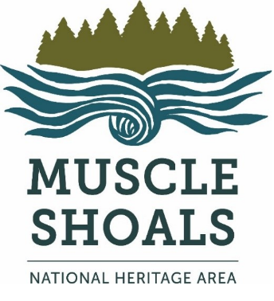
Maximum fieldtrip grant: $200
Eligible schools: Any elementary or secondary school in the six counties of the MSNHA -- Colbert, Franklin, Lauderdale, Lawrence, Limestone, Morgan.
Criteria: Grant applications must be made at least one month before date of fieldtrip. Fieldtrips must be educational & take place within the six MSNHA counties. If awarded a grant, teachers must send us post-trip pictures along with a description of the fieldtrip & how the grant helped make it possible. Email this documentation to msnha.una.edu. Failure to do so results in the school losing eligibility for future grants. Schools may apply for one grant per academic year.
How to apply: Copy & paste the form below onto a separate document. Provide requested information & email as an attachment to msnha.una.edu. Questions? Email Emily Rhodes, MSNHA grants director, at ebrhodes@una.edu.
Approval: Grant applications will be reviewed by the MSNHA staff. Applicants will be notified of grant awards via email.
Form:
Name of School
Address
County
Name of teacher
Email
Grade level of students going on fieldtrip
Date of fieldtrip
Field trip location
Cost per student
Amount requested
#####

