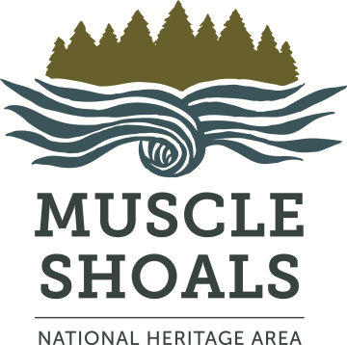
Muscle Shoals
National Heritage Area
Frequently Asked Grant Questions

Who is eligible?
Non-profits, local governments, businesses, museums, libraries, schools and other groups & organizations within MSNHA’s six counties: Colbert, Franklin, Lauderdale, Lawrence, Limestone & Morgan. Grantees with existing open applications can’t apply for additional grant funds for the same project unless other arrangements are made. See Grant Guidelines at msnha.una.edu.

What projects are eligible?
Projects must be located in & support the mission of the MSNHA & be linked to an MSNHA theme. Past projects have included interpretive signage, archive digitization, oral-history collections and cultural & historic reenactors. Grants viable for twelve months. See Grant Guidelines, msnha.una.edu.

How do I apply?
Instructions & forms are at msnha.una.edu. All grant submissions & correspondence are via email-- ebrhodes@una.edu

When do I apply?
Check msnha.una.edu & our Facebook page for announcements of grant cycles & deadlines.

What happens after I apply?
We’ll email you confirmation when we receive your application. Then qualified & objective grant readers review & score it. We may need to ask you for clarification or additional documentation at this point. Within thirty days of the application deadline, we’ll email you regarding the status of your application. Then, if your application is approved, we’ll prepare your contract, have it reviewed & signed by the appropriate UNA department heads, & then email it to you. As soon as you sign & date the contract & return it to us, it’s actionable. Grant awards are contingent on approval of final reports.

How are grants paid?
Awards are reimbursable amounts of $1,000-$7,500 & aren’t official until both parties sign contract. No money spent before you sign your contract will be reimbursed. Reimbursement is made only after required final-reporting documents are submitted & approved. In addition, MSNHA grants require a 1:1 match. See Grant Guidelines at msnha.una.edu.

What do “actionable,” “reimbursable” and “1:1 match” mean?
“Actionable” means that your contract isn’t in effect until you sign & date it--you can’t use any expenses or match contributions made before that date in your final reporting. “Reimbursable” means that you spend the money first & MSNHA reimburses you after your final report is submitted & approved. “1:1 match” means that in addition to paying your expenses (the amount agreed upon in the contract), you invest an equal amount into the project through additional expenses or in-kind contributions such as volunteer labor & goods-and-services donations. For example, if you request $5,000 for interpretive signage, you have to 1) pay that $5,000 first & then we reimburse you and 2) invest an additional $5,000 into the interpretive-signage project through more expenses or in-kind contributions.

When will I receive the check?
MSNHA does not write the grant award checks --UNA does. Once you submit your final report & documentation, your paperwork goes to various federal & university offices for approval before you receive your check. The best way to avoid delays is to meticulously follow all instructions & contact us as soon as you have a question or the terms agreed to in your contract change.

Will MSNHA help me with the application?
If you submit a draft of the application no later than 30 days before your deadline, MSNHA will review it for completeness & notify you of missing elements. See Grant Guidelines at msnha.una.edu.

How many grants will be awarded?
The number of grants awarded each cycle will vary. Applicants not approved may reapply in the next cycle. MSNHA has a limited amount of funds available to award grants; once those funds are depleted, the grants program will be suspended & will reopen once the next fiscal year’s budget is approved.

How will I be notified if I’ve received an award?
Applicants are notified of their status within 120 days of the deadline. All correspondence is via email.

Any other comments or questions? Contact Emily Rhodes, MSNHA grants coordinator, ebrhodes@una.edu or (256) 765-5028.

