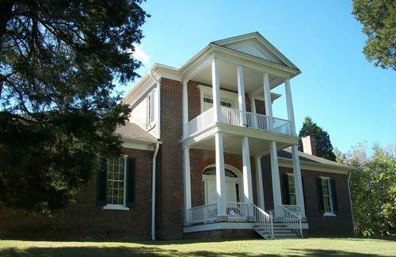
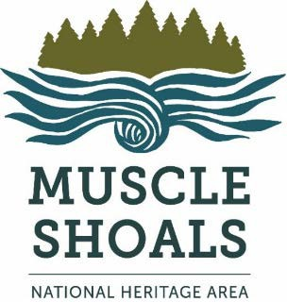
Architecture in the MSNHA

The Muscle Shoals Heritage Area (MSNHA) is filled with diverse architectural styles. Some excellent examples of early nineteenth century designs still remain in the MSNHA. Many modern styles can be seen as well, such as Frank Lloyd Wright’s Rosenbaum House in Florence, which is considered the best example of his Usonian style of architecture.

Federal Architecture
Federal-style architecture dominated the architectural landscape from the late eighteenth century to the early nineteenth century. Federal style is uniquely American and was evolved from the more elaborate, European Georgian architecture.

Federal-style houses are characteristically understated and typically are simply square or rectangle shaped. Houses of this style are often two or three stories high and lack the intricate front columns of other houses from the era.

Examples of Federal architecture in the MSNHA:

Colbert County:
Belle Mont (1828, Tuscumbia) (pictured to the right) Old Brick Presbyterian Church (1828, Muscle Shoals) John Daniel Rather House (1823, Locust Hill)

Lauderdale County:
George Coulter House (1827, Florence) Karsner-Carroll House (1831, Florence)
Sweetwater Plantation, Gov. Robert Patton House (1835, Florence)
Sannoner Historic District (Houses completed various years, Florence)

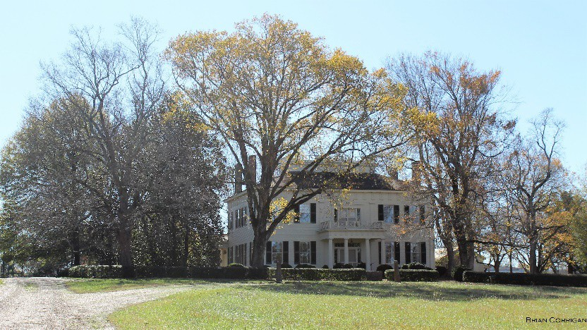
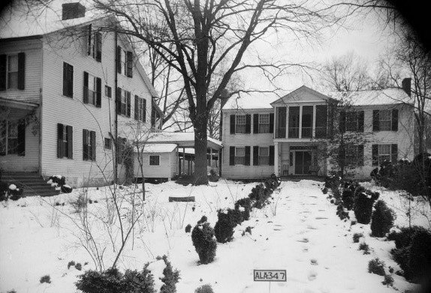
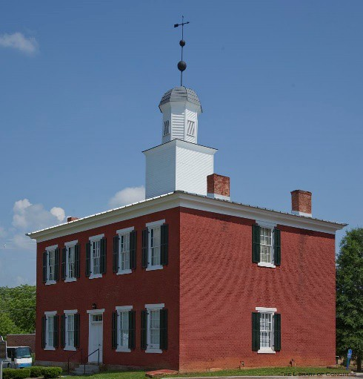
Lawrence County:
John McMahon House (1828, Courtland)
Pond Spring, The General Joe Wheeler Home- Sherrod House (1830s, Hillsboro) (pictured to the right)

Limestone County:
George S. Houston Historic District (Houses completed various years, Athens)
Gov. George Smith Houston House (1835, Athens)

Morgan County:
Somerville Courthouse (1837, Somerville) (pictured to the right)

Revival Styles of the Nineteenth and Twentieth Centuries

As British influence faded in America following the War of 1812, architects looked for inspiration elsewhere. Greek Revival architecture was one way Americans paid tribute to the birthplace of democracy, Greece. Many of the federal government buildings in Washington,
D.C. were built in this fashion, which is characterized by large columns, gables with pediments, and rotundas. Greek Revival architecture remained popular until the Civil War.

Another popular style of architecture of the nineteenth century was Gothic Revival, which took inspiration from the architecture of the medieval period. Not only a popular choice for the design of homes, many congregations constructed churches in the Gothic Revival style. Pointed arches, steeply pitched roofs, and castle-like turreted towers were commonly used elements.

Examples of Revival Style architecture throughout the MSNHA:

Colbert County:
Barton Hall – Greek Revival (1840s, Cherokee) (pictured to the right) Johnson's Woods – Classical Revival (1837, Tuscumbia)
Felix Grundy Norman House – Greek Revival (1851, Tuscumbia)
The Oaks – Gothic Revival (1820s, Tuscumbia)
Preuit Oaks – Greek Revival (1832,

Leighton)
Sheffield Downtown Commercial District – Classical Revival (Various years, Sheffield)

Rogers Hall

Lauderdale County:
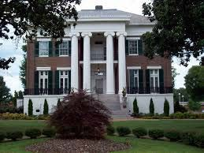
College Place Historic District (Various years, Florence)
Courtview (Rogers Hall) – Greek Revival (1855, Florence) (pictured to the left)
Downtown Florence Historic District (Various years, Florence)
Larimore House – Gothic Revival (1870, Florence) Locust Street Historic District – Late 19th and 20th Century Revivals (Various years, Florence) Sannoner Historic District – Greek Revival (Various years, Florence)
Southall Drugs – Italianate Revival (1900, Florence)

Walnut Street Historic District – Late 19th and 20th Century Revivals, Colonial Revival (Various years, Florence)
Wesleyan Hall – Gothic Revival (1856, Florence)
Wilson Park Houses District – Colonial Revival (Various years, Florence)
Wood Ave. Historic District – Colonial Revival, Tudor Revival (Various years, Florence)

Lawrence County:
Courtland Historic District – Colonial Revival (Courtland)
Goode-Hall House (Saunders House) – Classical Revival (1824, Town Creek)
Pond Spring The Joe Wheeler Home – The Wheeler House – Second Empire (1870s, Hillsboro)

Limestone County:
Athens Courthouse Square Commercial Historic District – Classical Revival, Late Gothic Revival, Greek Revival (Various years, Athens)
Athens State College Historic District – Greek Revival, Other Late 19th and 20th Century Revivals (Various years, Athens)
George S. Houston District – Late 19th and 20th Century Revivals (Various years, Athens)
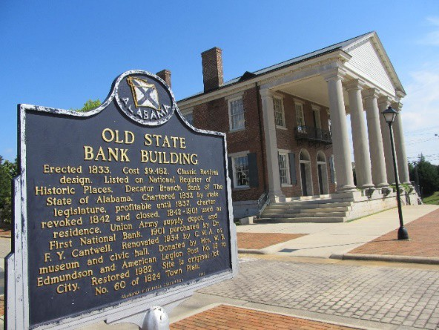
Robert Beaty Historic District – Mid 19th Century Revivals (Various years, Athens)
Woodside – Greek Revival (1861, Belle Mina)

Morgan County:
Bank Street Historic District – Late 19th and 20th Century Revivals (Decatur)
Forest Home – Greek Revival (1856, Trinity) Hartselle Downtown Commercial Historic District – Late 19th and 20th Century Revivals (Hartselle) New Decatur-Albany Historic District – Late 19th

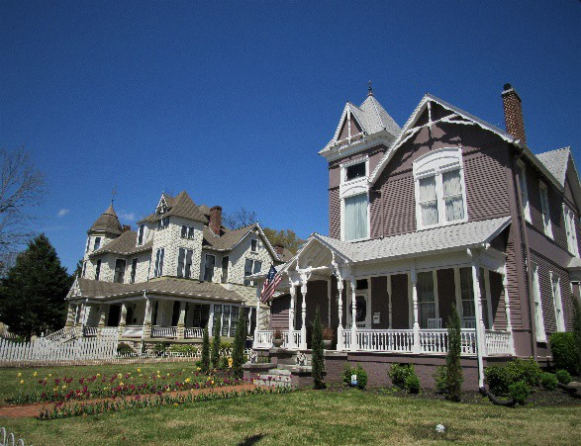
and 20th Century Revivals (Decatur)
State Bank Building (1833, Decatur) (pictured to the right)

Victorian Architecture

Victorian architecture is so named because of the English monarch who was ruling at the time of this style of architecture’s popularity— Queen Victoria. Victorian style architecture can be a considered a combination of many different revival styles including elements of Italian, Venetian, and Gothic. Many homes in this style feature bright colored trim and some have stained glass windows. Towers and turrets were popular also, which epitomizes the Victorian’s intricate and ornate style.

Examples found throughout the MSNHA:

Lauderdale County:
Locust Street Historic District (Various times, Florence) Sannoner Historic District (Various years, Florence) Walnut Street Historic District (Various years, Florence) Wood Ave. Historic District (Various Years, Florence) (pictured to the right)

Morgan County:
Albany Heritage Neighborhood Historic District (Various years, Decatur)
Bank Street Historic District (Various years, Decatur)
New Decatur-Albany Historic District (Various years, Decatur)

Craftsman and Bungalow Styles

Both the Craftsman and the Bungalow design were popular choices for homes in the early twentieth century. These styles were a huge jump from the grandeur favored in Victorian houses as the design was focused more on functionality. Both styles feature low-pitched roofs with exposed rafters and tend to be either one or two stories. The biggest distinction between the two is that Craftsman style homes feature more fine detail.

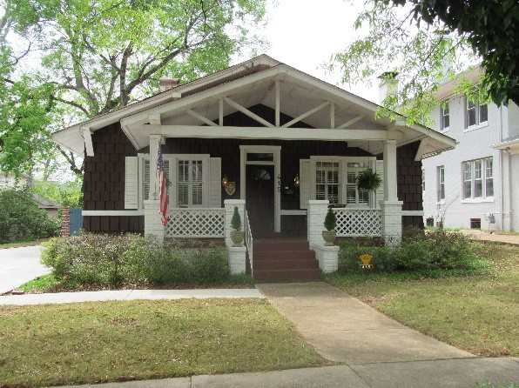
Examples of these throughout the MSNHA:

Colbert County:
Tuscumbia Historic District (Various years, Tuscumbia)

Lauderdale County:
Cherry Street Historic District (Various years, Florence) College Place Historic District (Various years, Florence) Sannoner Historic District (Various years, Florence) (pictured to the right)

Seminary-O'Neal Historic District (Various years, Florence)
Walnut Street Historic District (Various years, Florence) Wood Avenue Historic District (Various years, Florence)

Lawrence County:
Courtland Historic District (Various years, Courtland)

Limestone County:
George S. Houston Historic District (Various years, Athens)

Morgan County:
Albany Heritage Neighborhood Historic District (Various years, Decatur) Bank Street Historic District (Various years, Decatur)

Modern Architecture

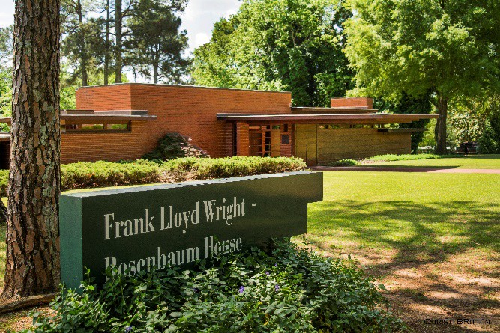
The Shoals is home to some of the finest examples of modern architecture in the South, most notably the Rosenbaum House designed by famed architect Frank Lloyd Wright. The Rosenbaum House is an early example of Wright’s Usonian style. Wright designed Usonian houses to not interfere with the natural landscape. The homes were constructed out of materials native to the region. The Rosenbaum House is the only Frank Lloyd Wright house open to the public in Alabama.

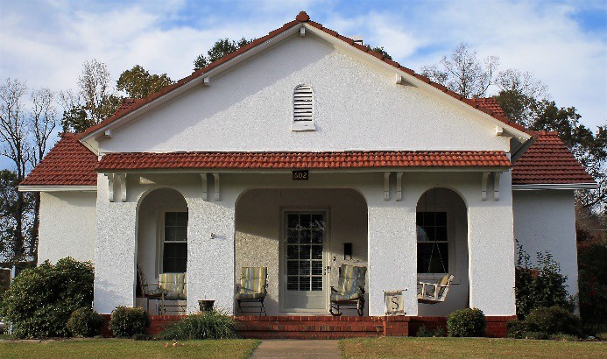
Sheffield is home to Nitrate Village One, which was a community of white stucco houses built by the US government for the workers at a local World War I nitrate plant. The streets of this community were laid out in the shape of the Liberty Bell.

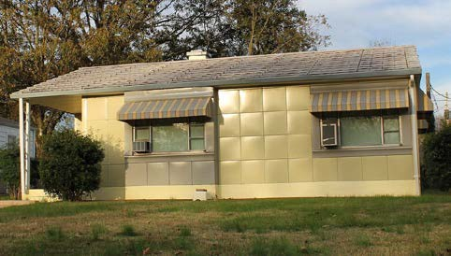
Also in the area are several Lustron houses, which were mass-produced, prefabricated houses made in response to the large number of returning troops in need of houses following World War II. These houses were made of steel and were extremely durable. The E.H. Darby Lustron House in Florence was built by Elton Darby, one of the co-owners of Southern Sash, the Lustron house dealer in the Shoals. The Lustron house pictured here is located on York Terrace in Sheffield.

Sears and Roebuck houses were also built in the area from plans and materials ordered from the Sears catalog. Sears offered more than 370 design plans of a variety of architectural styles including Colonial, bungalow, and Tudor revival.

