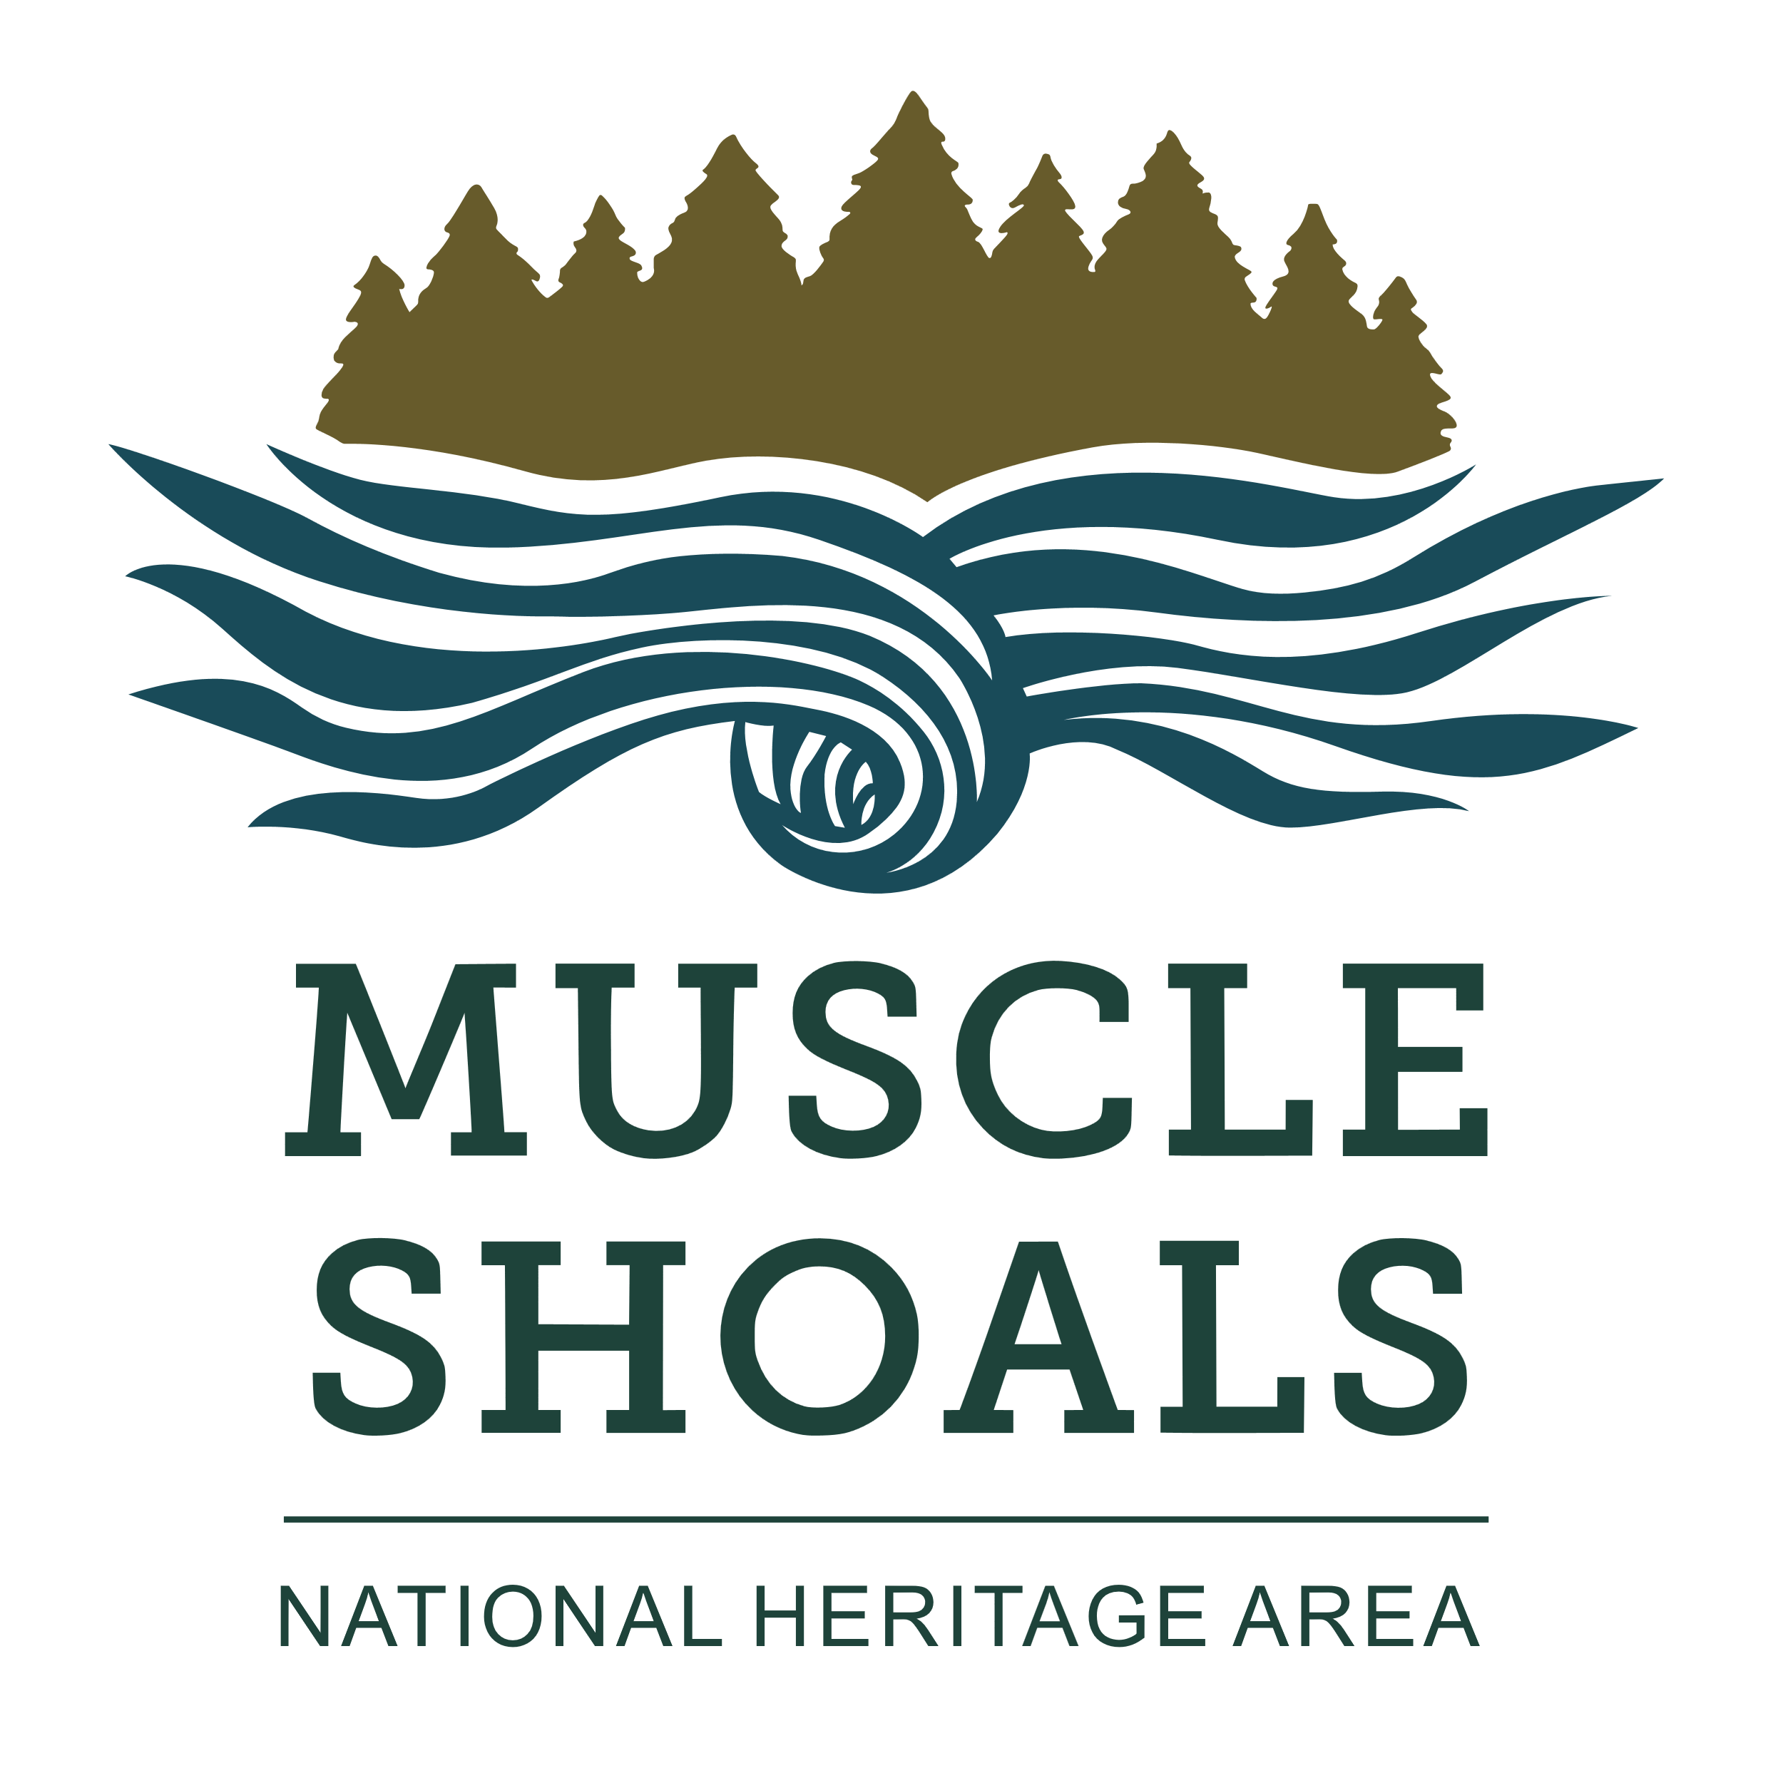**Muscle Shoals National Heritage Area Grant, Partnership and Sponsorship Guidelines**

**Who we are & what we do:** The Muscle Shoals National Heritage Area, which operates under the University of North Alabama, was designated by Congress in 2009 to preserve history & culture in the Tennessee River’s northwest Alabama counties: Colbert, Franklin, Lauderdale, Lawrence, Limestone & Morgan. We promote cultural tourism through education, preservation & conservation. Our mission is to inform & educate; develop & interpret historic sites; create living-history experiences; and chronicle landscape evolution, for the largest audience possible.

**Grants**

**What we fund:** Reimbursable amounts of $1,000-$7,500 per project in categories of:

● Museum and Archival Collection Assessment -- Hiring a consultant to address preservation needs or problems such as establishing environmental monitoring programs and developing plans for improving environmental conditions, security, or fire protection for collections; studying light levels in exhibition and storage spaces and recommending appropriate methods for controlling light and reducing damage to collections; developing detailed plans for improving storage or rehousing a collection; or assessing conservation-treatment needs of selected items in a collection.

● Historic Preservation -- Purchasing supplies and paying labor costs for basic preservation and preservation projects.

● Interpretation -- Enhancing museums & sites by developing document/volunteer training programs, cataloging & researching collections, writing exhibit text & other interpretive materials, developing long-term interpretive plans, installing interpretative panels, researching & installing historical markers and developing & printing educational materials.

● Workshops -- Funding workshops & training sessions for staff, volunteers & others.

● Local History and Archiving -- Initiating national & state historic registrations; developing cemetery restoration programs; digitizing documents and photos; and preserving collections such as books & journals, archives & manuscripts, prints & photographs, moving images, sound recordings, architectural & cartographic records, decorative & fine art objects, textiles, archaeological & ethnographic artifacts, furniture and historical objects.

● Events – Includes plays connected to the history and culture of the MSNHA, walking or driving tours, talks by professionals connected to the natural, cultural, and historical resources of the MSNHA, festivals that have a connection to one of the MSNHA themes.

● Musical productions and art projects – Presenting performances and showings that are related to MSNHA’s historical and cultural themes, promote the continued development of Muscle Shoals music culture, and are open to the public.

● Recreation Planning and Programming - Planning projects for hiking/running/biking trails, water access points on the Tennessee River and tributaries for kayaking/canoeing, park improvements, and other planning projects connected to recreation. Programming for recreation events (e.g. paying a facilitator to lead a kayak instruction workshop) and purchase of recreation equipment (e.g. mountain bikes/kayaks/stand up paddle boards).

● Environmental – Research projects on the MSNHA’s ecosystems, development of pollinator habitat/native plant gardens, native habitat restoration projects, environmental stewardship events, and environmental review for federally-funded projects.

**Who and what are eligible:** Non-profits, local governments, businesses, schools and other groups & organizations may apply. Applicants and projects must be in MSNHA’s six-county region. Projects must be linked to MSNHA’s mission & one of its three themes and fit within a category detailed above. Grantees with an open application can’t apply for additional funds for the same project until they've completed that project’s scope of work unless other arrangements are made.

**Matching contributions:** Applicants must provide at least a dollar-for-dollar match; we encourage overmatch. Match & overmatch must be from non-federal sources: foundation or private-sector grants, the applicant organization, project partners, in-kind non-cash contributions from professionals and/or volunteers ($28.92/hour, $12.50/hour students participating as part of an enrolled-course assignment, verified hourly rate for professionals) or any combination thereof. In-kind contributions may be labor, services, materials, equipment, supplies, and/or travel expenses necessary for project objectives. Purchases of real property, overhead & general administrative costs don’t count toward matches. Matching & overmatching contributions must begin after grant’s award date. Use website form(s) for submitting [volunteer](https://msnha.una.edu/resources/community-grants-program/sign-in-forms-timesheets-for-grant-match/) & [in-kind](https://msnha.una.edu/wp-content/uploads/2023/09/MSNHA-In-Kind-Donation-Form.pdf) documentations. Please review the [MSNHA Match Guide](https://msnha.una.edu/wp-content/uploads/2023/09/MSNHA-Match-Guide.pdf) so you are clear on match documentation requirements.

**How to apply:**

● Fill out [MSNHA Grant Application](https://msnha.una.edu/grant-form/). If you have any questions, please contact Terah Klein at [tklein@una.edu](mailto:tklein@una.edu).

● Expenses & match/overmatch contributions submitted in your final report MUST fall between the project’s start & end dates on the application. Anything dated outside of that range will not be accepted. Let us know if your project requires performance or venue deposits before contract is signed.

● Expenses for reimbursement and contributions to match & overmatch must be specific. These will be included in your contract, and documentation must be submitted with your final report. Include a project budget (revenues and expenses) as specified in the application.

**How applications are scored:**

● MSNHA selects qualified volunteer scorers. Scorers remain anonymous & do not evaluate applications with which they have potential conflicts of interest.

● Scoring categories include contributions to MSNHA (sustaining our mission & fitting into one of our three themes), innovative approach, potential to reach goals & objectives, clarity of proposal and budget appropriateness. Applicants may request copies of their scoring sheets.

● Extra points awarded for overmatch.

**Terms of grant awards:**

● Grant amount -- $1,000-$7,500 per proposed project. Funds are provided via reimbursement; grant funds are released only after project costs are incurred & paid for by the grant recipient. Expenses incurred before the date of the grant’s approval will not be reimbursed. MSNHA must receive applicant’s signed contract before any work to be covered by the grant award begins. Please note that while the MSNHA wishes to fund all grant applications in full, at times the MSNHA funds at a lower amount than requested.

● Expenses to be reimbursed & match and overmatch to be submitted must be specified in the application & contract and documented in the final financial report. MSNHA will release funds only for those approved expenses & matching contributions. Notify MSNHA before the project end date if revisions to the contract are necessary.

● Grantee must submit the [Grant and Partnership Final Report Form](https://msnha.una.edu/online-forms/grant-and-partnership-final-report-form/) by the deadline in your contract. Expenses & match contributions must be those specified in contract. Use the website forms for volunteer sign-ins & documenting in-kind contributions of goods and services.

● MSNHA grant applications are rolling. On October 1, the MSNHA will open grants and announce the amount of fund available for the fiscal year. Once all funds for the year are allocated, grants applications close. This closing of applications will be noted on the MSNHA website. Applications will open again on October 1 the following year.

● Award period -- Grants are viable for one year from the project start date. If recipient can’t complete the project within the agreed-upon time, including adjustments to original schedule, MSNHA will terminate the contract.

● Grant contract -- Funds are administered through a contract between MSNHA and the applicant. The award is not official until all parties have signed, and no money spent before MSNHA receives the signed contract will be reimbursed. Funds are not released until the grant recipient submits the agreed-upon documentation and MSNHA approves it.

● Project changes -- MSNHA must approve changes in the grant contract prior to initiation of such changes & prior to final-report submission. Email MSNHA about requested changes.

● Grant acknowledgment/publicity -- Grantees must sign the provided [publicity agreement](https://msnha.una.edu/wp-content/uploads/2023/09/MSNHA-Grants-publicity-agreement.pdf) & acknowledge MSNHA in all materials pertaining to the grant award & project. Grantees must notify Congressional & state representatives in writing that their project has received an MSNHA grant award through MSNHA. Include copies of letters & publicity with final report.

● Final reports – Please submit the [Grant and Partnership Final Report Form](https://msnha.una.edu/online-forms/grant-and-partnership-final-report-form/) by the deadline included in your contract.

● Please note that MSNHA does not write the grant award checks -- UNA does. Once you submit your final report & required documentation, your paperwork embarks on a weeks-long process through various university offices until everything is approved & you receive your check. The best way to avoid delays is to scrupulously follow all instructions & contact us as soon as you have a question.

● A short time after project completion, MSNHA staff may visit you to document proof of completion for UNA auditors. Alternatively, MSNHA may require photos & a brief wrap-up of the project.

**Grantee responsibilities** –Grant awards from MSNHA are made with federal funds received from the National Park Service. Because the grant dollars are federal in origin, grant recipients must comply with applicable federal regulations regarding the use and administration of federal funds. Grants must also follow state regulations.

● Code of Federal Regulations. The following Federal regulations are incorporated by reference into this Agreement (full text can be found at <http://www.ecfr.gov>:)

*a) Administrative Requirements: 2 CFR, Part 200 – Uniform Administrative Requirements, Cost Principles, and Audit Requirements for Federal Awards, in its entirety;*

*b) Determination of Allowable Costs: 2 CFR, Part 200 – Uniform Administrative Requirements, Cost Principles, and Audit Requirements for Federal Awards, Subpart E; and*

*c) Audit Requirements: 2 CFR, Part 200 – Uniform Administrative Requirements, Cost Principles, and Audit Requirements for Federal Awards, Subpart F.*

d) Code of Federal Regulations/Regulatory Requirements: 2 CFR Part 182 & 1401, “Government–wide Requirements for a Drug–Free Workplace”; 2 CFR 180 & 1400, “Non–Procurement Debarment and Suspension”, previously located at 43 CFR Part 42, “Governmentwide Debarment and Suspension (NonProcurement)”; 43 CFR 18, “New Restrictions on Lobbying”; 2 CFR Part 175, “Trafficking Victims Protection Act of 2000”; FAR Clause 52.203–12, Paragraphs (a) and (b), Limitation on Payments to Influence Certain Federal Transactions; 2 CFR Part 25, System for Award Management ([www.SAM.gov](http://www.sam.gov)) and Data Universal Numbering System (DUNS); and 2 CFR Part 170, “Reporting Subawards and Executive Compensation.”

● Grantees must comply with all applicable federal laws including but not limited to Section 106 of the Historic Preservation Act, Secretary of Interior Standards, the Native American Graves Protection and Repatriation Act, the National Environmental Policy Act, Title IV of the Civil Rights Act of 1964, Title IX of the Education Amendments of 1972, The Age Discrimination Act of 1975, and the Americans with Disabilities Act.

● Grantees must allow inspection of program records and project by MSNHA and authorized federal agencies during the project and for up to three years following project completion.

**Timeline and checklist for grant process:**

1. Read these guidelines & the grant application carefully to ensure your project meets all criteria & you can provide all required documentation. Incomplete applications & those using forms other than those provided will be discarded.
2. Submit application using all required forms.
3. We’ll email you immediately to verify receipt of your application & notify you of our funding decision within 45 days of the receipt of your application. Funding of your grant award is contingent on approval of final report.
4. MSNHA prepares your grant contract, a legal document stating the terms of your grant project. What’s specified in the contract must be what exactly what you submit in your final report. Email us with requests for contract revisions (start & end dates, scope & purpose of work, expenses & match/overmatch contributions) during the project. Once you submit your final report, the contract cannot be revised. Your final report will be approved & your reimbursement check sent only if the start & end dates, scope of work, purpose of work, expenses & match/overmatch contributions in your final report are exactly the same as specified in your contract.
5. Your contract is reviewed by various University of North Alabama offices. We may come back to you with requests for additional information & clarifications as needed.
6. We email you your contract. Please review it carefully to ensure that all information is correct & you can provide all required documentation. Email us immediately if something needs to be changed. When you’re sure everything is correct, notify our office and the agreement will be sent through AdobeSign for all signatures. The date of the final signature must be on or before the project’s start date--your project cannot start until after all parties have signed the contract. Once all parties have signed, the contract is actionable & you may begin your project. Save a copy of the signed agreement for your records.
7. Along with your contract, we’ll also email you the publicity agreement. Print it, sign & date it, save a copy for yourself & email us a copy.
8. As your project progresses, we’ll check in with you periodically. Email us immediately if you need to make a change in anything agreed to in the contract. Your final reports must duplicate EXACTLY what’s specified in the contract. For example, changes in vendors or budget amounts must be reported immediately and during the performance period.
9. Submit final report using the [Grants and Partners Final Report Submission form](https://msnha.una.edu/online-forms/grant-and-partnership-final-report-form/). Use required forms & upload required documentation (outlined in your contract) to ensure full reimbursement. Read guidelines on the final-report forms carefully; final reports that are incomplete, incorrect and/or do not duplicate exactly what’s specified in the contract will not receive full reimbursement.
10. UNA mails your check to your mailing address.

**Partnerships:**

The Muscle Shoals National Heritage Area also forms partnerships for up to five-years to provided sustained support to organizations who have either successfully completed a grant with the MSNHA, have a preexisting relationship through collaborative projects, or serve as a site of an existing/potential MSNHA interpretive center. Partners also supply the MSNHA with a stable source of match funding, which is a major factor in partnership selection and development. Prospective partners are evaluated and approved by the MSNHA Advisory Board. The partner and MSNHA sign an overall partnership agreement and then an addendum is developed for each partnership project or event.

**Terms of Partnerships:**

● Partnerships range in funding, but do not exceed $10,000. Funds are provided via reimbursement; partnership funds are released only after project costs are incurred & paid for by the partner. Expenses incurred before the date of the partnership’s approval will not be reimbursed. MSNHA must receive partner’s signed contract before any work to be covered by the partnership award begins.

● Expenses to be reimbursed & match and overmatch to be submitted must be specified in the application & contract and documented in the final financial report. MSNHA will release funds only for those approved expenses & matching contributions. Notify MSNHA before the project end date if revisions to the contract are necessary.

● Partners must submit the [Grant and Partnership Final Report Form](https://msnha.una.edu/online-forms/grant-and-partnership-final-report-form/) by the deadline in your contract. Expenses & match contributions must be those specified in contract. Use the website forms for volunteer sign-ins & documenting in-kind contributions of goods and services.

● Award period – Partnership contracts are viable for one year from the project start date. If recipient can’t complete the project within the agreed-upon time, including adjustments to original schedule, MSNHA will terminate the contract.

● Partnership contract -- Funds are administered through a contract between MSNHA and the partner. The award is not official until all parties have signed, and no money spent before MSNHA receives the signed contract will be reimbursed. Funds are not released until the partner submits the agreed-upon documentation and MSNHA approves it.

● Project changes -- MSNHA must approve changes in the partnership contract prior to initiation of such changes & prior to final-report submission. Email MSNHA about requested changes.

● Partner acknowledgment/publicity -- Partners must sign the provided [publicity agreement](https://msnha.una.edu/wp-content/uploads/2023/09/MSNHA-Grants-publicity-agreement.pdf) & acknowledge MSNHA in all materials pertaining to the grant award & project. Partners must notify Congressional & state representatives in writing that their project is funded through an MSNHA partnership. Include copies of letters & publicity with final report.

● Final reports – Please submit the [Grant and Partnership Final Report Form](https://msnha.una.edu/online-forms/grant-and-partnership-final-report-form/) by the deadline included in your contract.

● Please note that MSNHA does not write the partnership award checks -- UNA does. Once you submit your final report & required documentation, your paperwork embarks on a weeks-long process through various university offices until everything is approved & you receive your check. The best way to avoid delays is to scrupulously follow all instructions & contact us as soon as you have a question.

**Partner responsibilities** –Partnership awards from MSNHA are made with federal funds received from the National Park Service. Because the funding is federal in origin, partners must comply with applicable federal regulations regarding the use and administration of federal funds. Partners must also follow state regulations.

● Code of Federal Regulations. The following Federal regulations are incorporated by reference into this Agreement (full text can be found at <http://www.ecfr.gov>:)

*a) Administrative Requirements: 2 CFR, Part 200 – Uniform Administrative Requirements, Cost Principles, and Audit Requirements for Federal Awards, in its entirety;*

*b) Determination of Allowable Costs: 2 CFR, Part 200 – Uniform Administrative Requirements, Cost Principles, and Audit Requirements for Federal Awards, Subpart E; and*

*c) Audit Requirements: 2 CFR, Part 200 – Uniform Administrative Requirements, Cost Principles, and Audit Requirements for Federal Awards, Subpart F.*

d) Code of Federal Regulations/Regulatory Requirements: 2 CFR Part 182 & 1401, “Government–wide Requirements for a Drug–Free Workplace”; 2 CFR 180 & 1400, “Non–Procurement Debarment and Suspension”, previously located at 43 CFR Part 42, “Governmentwide Debarment and Suspension (NonProcurement)”; 43 CFR 18, “New Restrictions on Lobbying”; 2 CFR Part 175, “Trafficking Victims Protection Act of 2000”; FAR Clause 52.203–12, Paragraphs (a) and (b), Limitation on Payments to Influence Certain Federal Transactions; 2 CFR Part 25, System for Award Management ([www.SAM.gov](http://www.sam.gov)) and Data Universal Numbering System (DUNS); and 2 CFR Part 170, “Reporting Subawards and Executive Compensation.”

● Partners must comply with all applicable federal laws including but not limited to Section 106 of the Historic Preservation Act, Secretary of Interior Standards, the Native American Graves Protection and Repatriation Act, the National Environmental Policy Act, Title IV of the Civil Rights Act of 1964, Title IX of the Education Amendments of 1972, The Age Discrimination Act of 1975, and the Americans with Disabilities Act.

● Partners must allow inspection of program records and project by MSNHA and authorized federal agencies during the project and for up to three years following project completion.

**Sponsorships:**

The MSNHA supports local events connected to the three themes of the MSNHA (Tennessee River, Muscle Shoals Music and Native American Heritage). They also support recreation events and programs that help to further the MSNHA’s goals of recreation development in the MSNHA. Sponsorships are between $500 and $1000 and are paid ahead of the event/program out of non-federal MSNHA funds. The MSNHA requests that the organization receiving the sponsorship track volunteer time during the event and submit such time on an MSNHA timesheet after the conclusion of the event, include the MSNHA name/logo on event materials, and tag the MSNHA in social media posts connected to the event. Applications are available [here](https://msnha.una.edu/online-forms/msnha-sponsorship-request-form/).

**For more information –** Terah Klein, Business Manager, MSNHA, UNA Box 5231 Florence, AL 35632-0001 (256) 765-5028 or [tklein@una.edu.](mailto:tklein@una.edu.)